**Visual Studio Code Installation Guide for Chromebook**

**Quick Links**

**Youtube Guide to Installation:** <https://www.youtube.com/watch?v=j-ThcVBqNO0>

**Online Guide for Installation:** <https://code.visualstudio.com/blogs/2020/12/03/chromebook-get-started>

**Installation Guide for Chromebook**

**Part 1: Enabling Linux on your Chromebook**

1. Open your **System Settings**, on the left panel, click on ‘**Advanced’** and under **‘Developers’**, **turn on** **Linux Development Environment.**
2. Click on **‘Next’**, leave the values as default and click on **‘Next’**. Wait for the installation to finish.

[Once the Linux environment has been set up, you will see a new terminal window popping up]

**Part 2: Installing Visual Studio Code**

1. Go to <https://code.visualstudio.com/download>
2. Click on the appropriate download package.

* For Chromebooks running an **Intel or AMD chip**, pick the .**deb** in variant **64 bit**
* If your Chromebook is running on an **ARM64 chip**, pick the **.deb** package in the variant **ARM64** instead

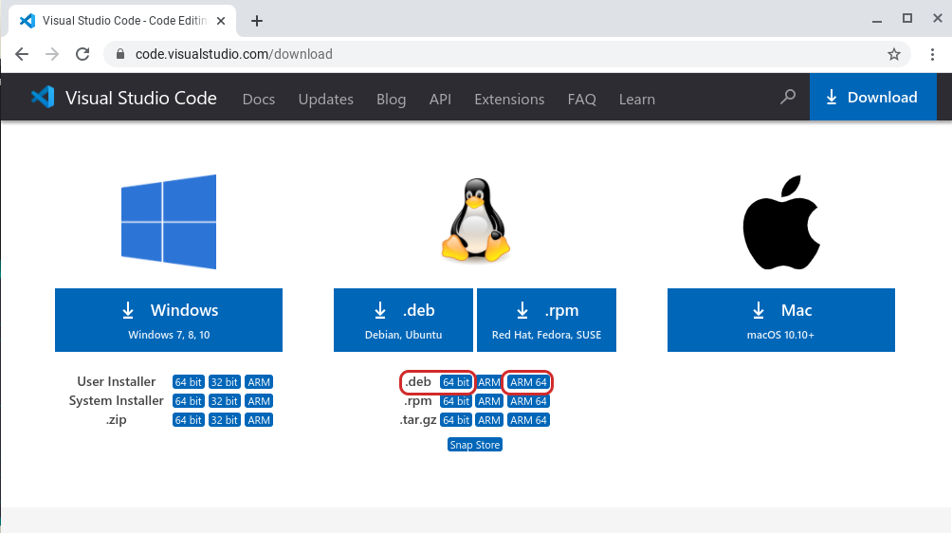

If you are unsure which kind of CPU your Chromebook is using, run the command **dpkg --print-architecture** in the Linux terminal to find out. You will see either **amd64** (for both Intel and AMD chips: pick the 64 bit variant for VS code) or **arm64** (pick ARM64)

To open **Linux Terminal,** press the **Search Key** on your Chromebook keyboard, type **terminal** in the search box and press **Enter.**

[<https://helpdeskgeek.com/how-to/how-to-open-the-linux-terminal-on-chromebook/>]

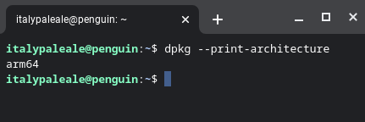

1. The package will be downloaded. Once the installer is downloaded, double click on the package and ‘Install app with Linux’

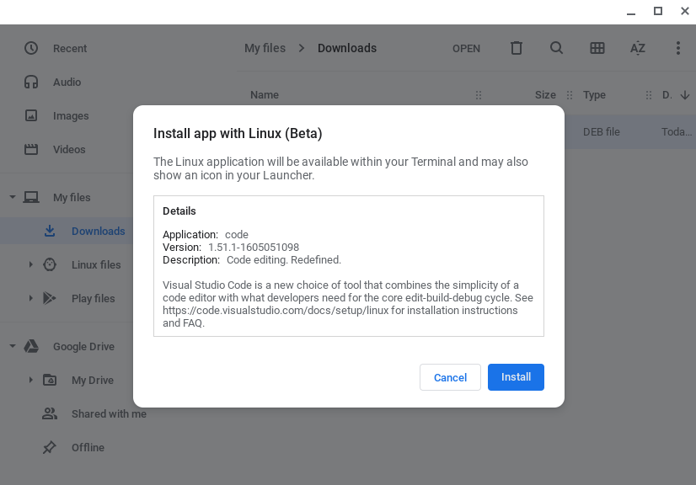

1. Click on ‘Install’ and let the installation run
2. Once the installation is completed, you will be able to launch Visual Studio Code

